Homework #2 – ITEC 3150 - Fall, 2018

Due Date: Monday, September 17, 2018 at 11:59 PM NO LATE ASSIGNMENTS ACCEPTED

Problem:

Part I:

Write a program that reads in your text file from Homework 1. The program will then write the Course objects using ObjectOutputStream (writeObject) to a new binary file. Turn in the program that converts the text file to binary with both binary and text files.

Complete Part I of Homework 2 and ***add an FX GUI that tracks and reports each time a course is read from the text file and output to the new binary file.***  Basically, counts how many records are read and written in real time.  You may need to pause between each record read so that the counter can visibly update.

TO PAUSE FOR 1/2 second -

Thread.sleep(500);

Part 2: - THIS IS A SEPARATE PROGRAM

Using homework 1 (yours or instructor solution), convert your user interface to a JavaFx user interface. The user should be able to view the contents of the Library. User should also be able to choose from the list of names and see all attributes of a particular item. Populate the GUI with names of the courses read in from the binary file created in part I. THIS PART SHOULD NOT READ FROM THE TEXT FILE.

Example Output of Program:

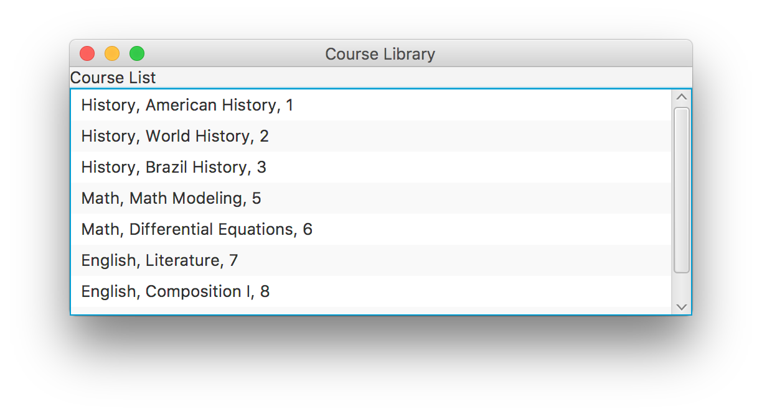

Double click of highlight row causes Details of the selected COURSE – IN A SEPARATE STAGE AND WINDOW:

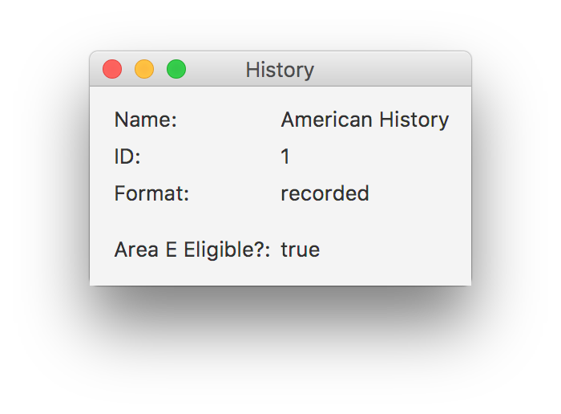

Learning Objectives:

1. Read/write binary files
2. Create a GUI using JavaFx
3. Allow user interaction to display contents of the library
4. Populate multiple Scenes/Stages in the GUI
5. Acknowledge user input (double click) in Java FX Gui

Grading Criteria: - only grading Part II. If Part I is not completed correctly Part II won’t work.

|  |  |
| --- | --- |
| Criteria | Points |
| Coding Standards | 15 |
| Read in binary file containing course list | 25 |
| Display course list in JavaFx GUI (suggest ListView) | 25 |
| Open second stage displaying detail information of course | 25 |
| JavaFX GUI’s Readable and user friendly | 10 |